EXPERIMENT 1
Code and Output:
Program 1: Implementation of operators.
Code:
class Operators{
public static void main(String[] args)
{
int num1 = 10 , num2 = 5 ;
System.out.println("Two numbers are: " + num1 + "," + num2 );
System.out.println("Addition:"+ (num1+num2));
System.out.println("Subtraction:"+ (num1-num2));
System.out.println("Multiplication:"+ (num1*num2));
System.out.println("Division:"+ (num1/num2));
System.out.println("num1 > num2:"+ (num1>num2));
System.out.println("num1 < num2:"+ (num1<num2));
System.out.println("num1 == num2:"+ (num1==num2));
System.out.println("(num1>num2)&&(num1!=num2):"+ ((num1>num2)&&(num1!=num2)));
}
}
Output:
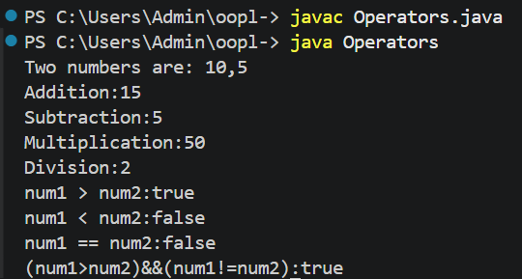
Program 2: Arithmetic Operators
Code:
import java.util.Scanner;
public class Main1{
public static void main(String[] args) {
Scanner sc = new Scanner(System.in);
float a,b,result;
int choice;
System.out.println("Enter First number:");
a=sc.nextFloat();
System.out.println("Enter Second Number");
b=sc.nextFloat();
System.out.println("Arithmatic Operations");
System.out.println("1.ADDITION");
System.out.println("2.SUBTRACTION");
System.out.println("3.DIVISION");
System.out.println("4.MULTIPLICATION");
System.out.println("5.MOD");
System.out.println("Enter choice:");
choice=sc.nextInt();
switch (choice) {
case 1:
result=a+b;
System.out.println("Result:" +result);
break;
case 2:
result=a-b;
System.out.println("Result:" +result);
break;
case 3:
result=a/b;
System.out.println("Result:" +result);
break;
case 4:
result=a*b;
System.out.println("Result:" +result);
break;
case 5:
result=a%b;
System.out.println("Result:" +result);
break;
default:
System.out.println("Invalid Choice");
}
sc.close();
}
}
Output:
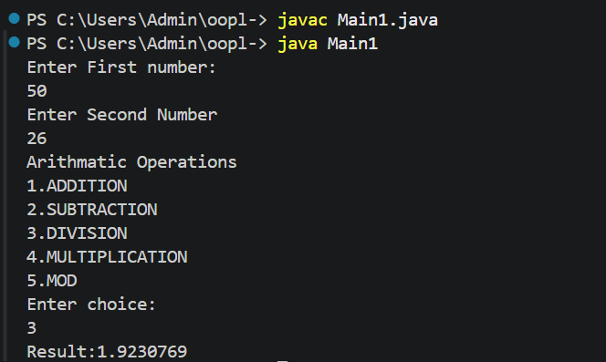

Program 3: Method Calling
Code:
public class MethodCalling{
int Addition(int a , int b ){
return a+b;
}
int multiply(int a , int b){
return a*b;
}
public static void main(String[] args) {
MethodCalling obj = new MethodCalling();
int sum = obj.Addition(10, 5);
int product = obj.multiply(10, 5);
System.out.println("Sum = " + sum);
System.out.println("Product = " + product);
}
}
Output:
